The Role of Social Media during the SARS-CoV-2 Outbreak in
Spreading Misinformation and Fear

Abstract
The use of social media is something that has increased during the period of the fight against SARS-CoV-2 as more people have to stay at home and distance themselves. Many have used social media as a source of information about the virus and how to prevent the spread, entertainment and also as a means to connect with loved ones for psychological support. However, the use of social media also facilitated the spread of misinformation and mass hysteria in the globe. The study aims to investigate how social media has facilitated the spread of misinformation during this SARS-CoV-2 pandemic and how it has affected the psychology of individuals. The methods used a quantitative survey carried out through questionnaire involving 360 respondents and analysis was carried out through descriptive analysis. Research results and findings show that respondents report feeling more fear from the rumors they heard rather than actual information about the virus. This study has facilitated more knowledge into the causes of mass hysteria during the spread of the pandemic.
Keywords: Social media, Covid-19, Society, SARS-CoV-2, Spreading Misinformation,

- Introduction
Social media have experienced exponential growth in the past decade and a half, thus becoming one of the most used sources of information globally. However, this growth of social media has exacerbated the spread of fake news. Social media are rarely subjected to the same level of scrutiny and censorship that conventional media go through. This means that social media platforms have the freedom to publish information freely, which can lead to the spreading of fake news. During this period of the coronavirus pandemic, the role that social media play in the current society has become more evident. Some of the benefits and challenges that are accompanied with the use of digital social media have been identified.
Firstly, the role of social media in helping to prevent the spread of the coronavirus disease of COVID-19 is evident. Social media have been instrumental in lessening the initial effects of the pandemic by offering information and enabling communication with friends and family (Francis, 2020). However, on the negative side, it has been challenging to ensure the reliability of the information spread over social media. Social media have also been instrumental in mitigating the psychological effects of the virus because they offer communication networks. During this period, physical movement and communication have become challenging, meaning that families and friends have become isolated from each other.
Social media have become a primary source of information for most individuals around the world (Hellewell et al., 2020). People turn to social media for expert opinions, virtual conversations, and information around the COVID-19 ailment. Individuals have used social media to share experiences as well as success stories with the disease and as a source of entertainment.
Due to these benefits, social media have become a central actor in this period of the COVID-19 breakout. They have been used by government agencies and other health-related international organizations as a means to spread instructions about the disease and health information regarding the mysterious virus. However, there are many web pages that are using this as an opportunity to take advantage of the unsuspecting public. There are some pages that have information with a much skewed interpretation of the virus. Their primary aim is to direct traffic to their pages rather than giving informative content with health and humanitarian considerations (Manderson and Levine, 2020).
Some social media sites are amplifying the crisis by playing into the anxieties that people have in these uncertain times. They do this by distorting the news to amplify the crisis and spread false rumors, which aims to create terror in people (Ho et al., 2020; Cascella et al., 2020). Others have created more fear in the hearts of many by emphasizing the circumstances that people living in the hardest-hit areas face. Some other individuals are promoting false drugs, which they purport to help address the disease.
Since this is a rapidly evolving situation that is hotly fueled by social media, it is important to scientifically study the phenomenon to better understand the relationship between social media, the spread of fake news, and how it has affected the psychological wellbeing of members of the public. This scholarship will facilitate decision making by key government agencies and corporations to enable better management of information dissemination to combat the effects of false news.

  - Objectives of the Study
1. Knowing the reasons for using social media during COVID-19 disease.
2. Knowing the topics covered by social media.
3. Knowing the contribution of social media to spreading rumors about the virus.
4. Knowing the impact of COVID-19 rumors on the social and psychological aspects of e the respondents.

  - Study Questions
- What are the reasons for using social media during COVID-19 disease?
- What topics were covered by social media?
- What is the contribution of social media to spreading rumors about the virus?
- What is the impact of the rumors of COVID-19 on the social and psychological aspects of the respondents?

- Literature Review
Human history has accounts of pandemics of biblical proportions that caused the devastation of large groups of people. The H1N1 influenza A virus caused one such outbreak in 1918 that came to be called the Spanish flu. This influenza virus inflected an approximated 500 million people at the time, which made up a third of the global population. When the pandemic was finally controlled, it had claimed anything between 25 and 50 million lives (Depoux et al., 2020).
The breakout of the coronavirus pandemic of 2019 began in the region of Wuhan in Hubei province China. It came to the attention of the authorities that a new virus was causing a severe form of pneumonia, especially among people with a history of contact with the sea food market in Wuhan (Zu et al., 2020). Since the initial identification of the virus, it has been able to spread to more than 190 other countries.
China was quick to respond to the cases of the virus in the country after the authorities were aware of it. Measures that the government used to contain the virus include travel cessation and total lockdown of the affected areas. The outbreak in China peaked in February and it was completely under control by the end of March. However, as the virus was controlled in China, it went out of control in territories out of China (Kupferschmidt, 2020).
In January and February of 2020, the virus spread to regions in Europe and the United States. By mid-March, Italy had become a new hotspot in Europe with a rapidly growing number of infections and fatalities. Spain, Germany, and the United Kingdom also reported high numbers of infection in March and April (Remuzzi and Remuzzi, 2020). However, infections reached their peak in the United States, which is currently being hardest hit by the pandemic.
The virus, which was initially called Novel Coronavirus 2019 nCoV and later SARSCoV-2, causes flu like symptoms in many patients, which can develop into pneumonia. More information about the virus is yet to be found out. However, specialists indicate that it spreads faster than the common cold and the flu (Gralinski and Menachery, 2020). The mortality rate of SARSCoV-2 is higher than that recorded for influenza and other respiratory diseases because human beings have not had prior contact with the virus to develop immunity. The mortality rate of the disease is between 5 and 3 percent, according to presently available information.
The rapid spread of the SARSCoV-2 virus, that causes the COVID-19 disease, has brought about panic and hysteria in the world. Governments have moved to protect their citizens from the rapid speed of the disease by initiating policies to limit human contact. Many governments issued directives to close schools as an initial measure to limit the spread of the virus (Zheng et al., 2020). All non-essential service providers were also incentivized to work from home with some countries and regions having to lockdown entire populations at their home (Anderson, Heesterbeek, Klinkenberg, & Hollingsworth, 2020).
However, this is not the first occurrence of human infection with a coronavirus that has animal origins. According to Pan et al. (2020), there have been three human infections with coronaviruses of animal origin. The first was disconcerted in November of 2002 in Guangdong Province China. This disease was, however, not given global recognition until March 15, 2003 when cases were reported in Guangdong, Hongkong, and Hanoi. The World Health Organization issued a global alert on the disease and it was named the Severe Acute Respiratory Syndrome (Parry, 2020). The pathogen that caused this disease was found to originate from bats with an intermediary host called a Palm Civet.
The second recorded incident of the spread of a coronavirus was identified in the Middle East in 2012. This new virus came to be called the Middle East Respiratory Syndrome. MERS CoV was first identified in Saudi Arabia and it came to spread to South Korea, France, the United States, and England among other states. However, the rate of spread was not high and as of 2019, 2468 individuals had been reported to have gotten infected by the virus. This strain of coronavirus was transmitted to humans from bats through camels as an intermediary host.
The novel coronavirus spread of 2019, has however, caused panic in the world like never experienced before. This is due to the rapid spread of information through social media (Cinelli et al., 2020). Firstly, SARSCoV-2 is much more infectious than the previous strains of coronaviruses that the world has contacted (Lipsitch et al., 2020; Liu et al., 2020). This means that many governments were lax to pass decisive policies to help limit the spread. This is what caused massive spread in communities in Europe and America (Meng et al., 2020; Pan et al., 2010).
The spread of the disease has caused uncertainty in the world, which has affected the global economy and the livelihoods of many middle- and low-income individuals (Sun et al., 2020). Since there has never been a global pandemic in the modern world with such great proportions, the globe is hyper aware. The use of social media has also made the public aware that people are suffering and dying from this disease. This has created even more fear and uncertainty.
A study conducted by Kouzy et al. (2020) indicates that the role played by social media during such a time is highly integrated and complex. From a sample of 673 tweets, it was found that 66 percent of Twitter traffic was posted by individuals as well as groups, and 19.2 percent was dispatched by verified Twitter accounts. The contents of the tweets indicated that 91.2 percent of the traffic contained serious content. Around 81.4 percent of tweets contained information about COVID-19, with around 70 percent tackling medical, public health, social, political, and financial information.
In total, 24.8 percent (n=153) tweets contained some form of misinformation while 17.4 percent (n=107) had information about COVID-19 that is unverifiable at the moment. The rate of misinformation was found to be higher among individual or group accounts at a rate of 33.8 percent (p<0.001). The level of misinformation was higher in unverified accounts as compared to verified accounts. There was 31 percent misinformation for unverified accounts and 12.6 percent misinformation for unverified accounts (p<0.001).
Tweets from public health accounts and healthcare accounts had the lowest rate of posting unverified information at 12.3 percent (p: 0.04). The number of likes or retweets that a tweet had did not have any relation to the authenticity of the contents of the tweet. This means that even tweets with misinformation and unverified information could get a high number of retweets and likes. This facilitated the spread of false information through social media.
The highest rate of misinformation and unverified information was discovered to be accompanied by the use of the keywords ‘#2019-ncov’ and ‘#corona’. The use of the keyword ‘#COVID-19’ had the lowest rate of unverified information and misinformation. The peak of social media searches of coronavirus increased in 2019, about 10 to 14 days before the daily incidences became high in China (World Health Organization, 2020). There is high prevalence of correlation between daily incidences and internet searches as well as social media searches with the maximum r>0.89 in all correlations (Li et al., 2020).
Evidence also shows that news of COVID-19 came to wider attention through the use of social media. There has been use of websites such as Flutrackers and ProMED to collect information from around the world (French and Monahan, 2020). These websites also allow for the timely access of medical information by interested parties. In 2012, the outbreak of the MERS CoV disease was made possible through the ProMED mail system and subsequent discussions that took place over Twitter. It is such a system that eight years later was able to intercept dissected messages in correspondence of the Wuhan Municipal Health Commission (Boulos and Geraghty, 2020).
During an outbreak, it is often difficult to distinguish between rumors and truth. However, the system used was able to intercept important key words such as “influenza” while excluding other strains of coronaviruses. It was anticipated that the Chinese government would silence the paramedics and healthcare system about the outbreak of the novel coronavirus in 2019. One of the first doctors to raise alarm about this disease was subjected to disciplinary action by the authorities for bringing attention to this disease before he tragically died from the same virus (Chung and Li, 2020; Huang et al., 2020).
The use of social media platforms such as YouTube and Twitter can profoundly facilitate the spread of untrue information due to the fundamental make-up of the algorithm. Individuals are shown messages that conform to the tastes and preferences of the users rather than the validity of the message.

- Research Design and Methodology
The study was conducted using a questionnaire that sampled questions about the demographic information of the respondents and their behaviors while utilizing social media. The sample of study included 360 replies from respondents ranging from less than 20 years old to over 50 years old. The survey was carried out through the use of questionnaires that were distributed to respondents through online delivery. The questionnaire was designed to capture social media use behaviors before and after the onset of COVID-19 by asking questions about the use of frequency before and after the breakout of the disease. Questions were also asked to establish behavior of use with and around other people and the favorite items that individuals like to access on social media. The reasons for using social media during the outbreak of COVID-19 and the social media topics of discussion around the virus have been investigated. The sentiments of the respondents about the spread of rumors and social media were also investigated through the use of a like-art scale.
The methodology of research chosen for this study is quantitative in nature. This means that investigations seek to numerical data on behaviors rather than opinions and views. It is optimal to use a quantitative survey in this research because the issue under investigation is highly integrated into social phenomena in a widespread manner. The independent variable of investigation is social media, while the dependent variable is people’s perception of truth and false information obtained from social media. The independent variable will be investigated to find out how it has affected the mindset of the public by helping in the dissemination of false news.

- Results and Discussion
In this section, the analysis of individual responses concerning social media contribution in spreading COVID-19 fear will be evaluated. Individual’s social media presence will be investigated. Their view on socialization platforms being contributors of spreading the fear on the pandemic will get analyzed. The aim of this section will be to collect data on social media influence during the COVID-19 pandemic. With individuals staying at home, they use these platforms a lot, making them influential in how they view the pandemic.
The sample also included 53.3 percent male respondents and 46.7 percent female respondents. This ratio indicates a balanced sample. These individuals were composed of diverse ages, ethnicity, cultural backgrounds, and religious beliefs. The analysis, hence was able to collect unbiased findings.
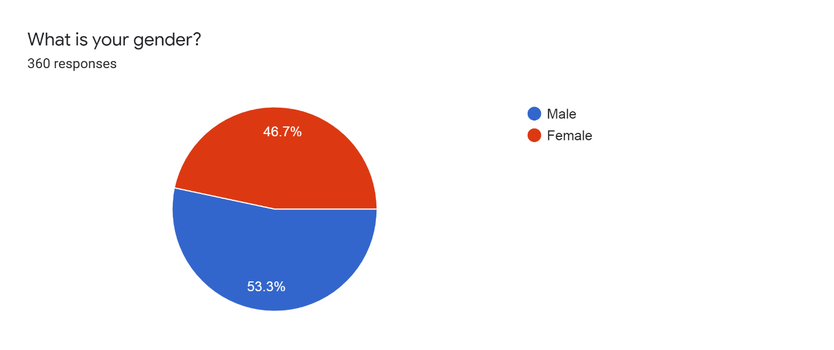
Figure 1: Gender Demographic

The largest number of respondents came from the Asian Pacific at 66.7 percent followed by the Middle East at 16.9 percent. Those from north America were 5.3%, European respondents were 4.5%, Africans were 2.1% while Latina Americans were 4.5%. This means that the sample does not represent a global warming respective but rather results from Asia predominantly.
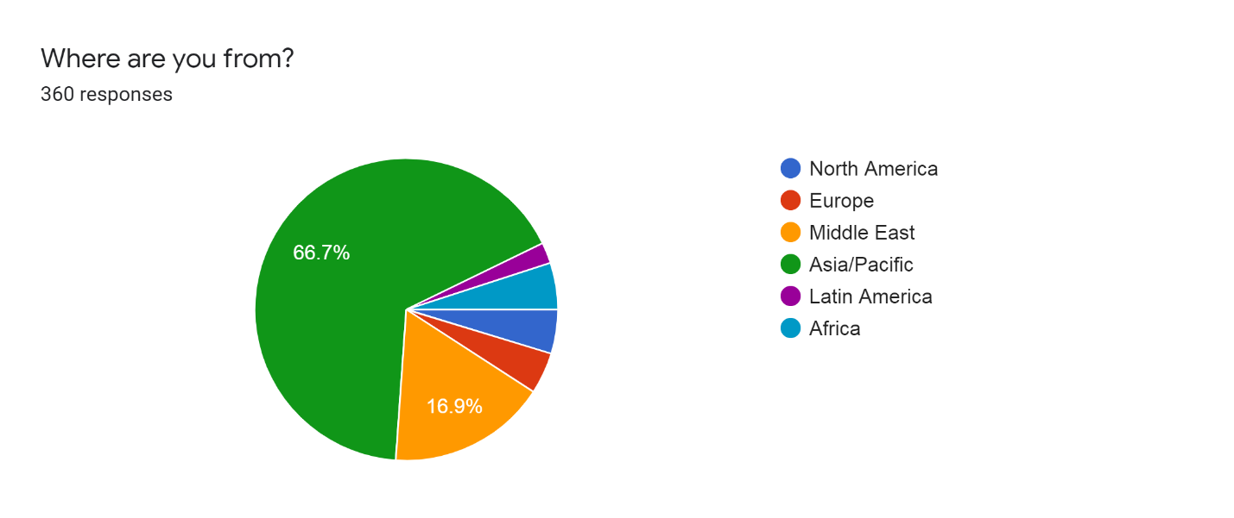
Figure 2: Sample Demographic

The study respondents were made up of 24.4 percent of individuals under the age of 20, 22.5 percent of respondents being between 21 and 30, 43.1 percent being between 31 and 50 and 10 percent being more than 50 years old. According to these results, it was clear that those below fifty years are the ones who rely on social media to get relevant news on the pandemic. These individuals are young and productive in such a manner that they would like to access the information about what happens in the world. Those from 31 to 50 years are the ones who responded more. This shows that the sample is made up of predominantly young adults and middle-aged adults.
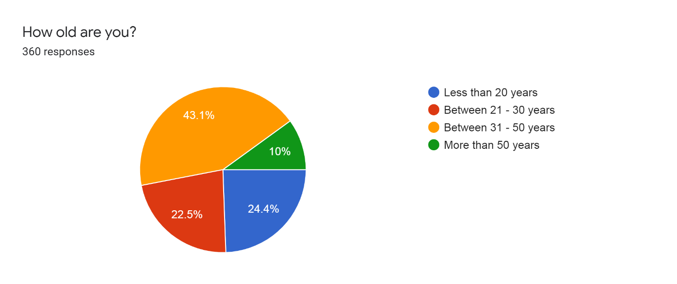
Figure 3: Age Demographic

The study sample was made up of 46.7 percent females and 53.3 percent male respondents. A majority of the respondents are students at 49.4 percent followed by public servants at 18.2 percent and private sector workers at 15.6 percent.
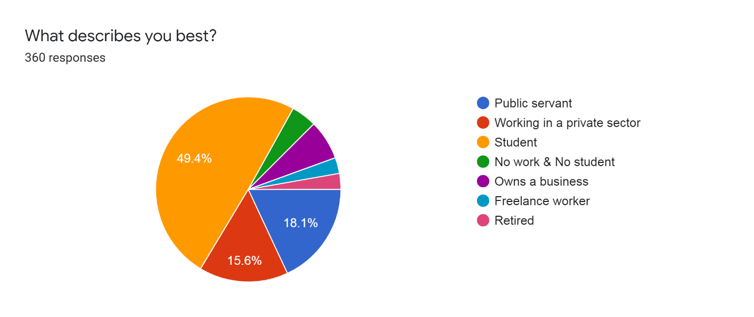
Figure 4: Occupation

From the 360 individuals who responded to the questionnaire, 31.1 percent recorded having used social media consistently for 2 to 4 hours daily, while 25.6 percent used it for 1 to 2 hours daily. The number of users who utilized social media for 4 to 6 hours daily was 23.1 percent with smaller groups using it for less than an hour and more than 8 hours.
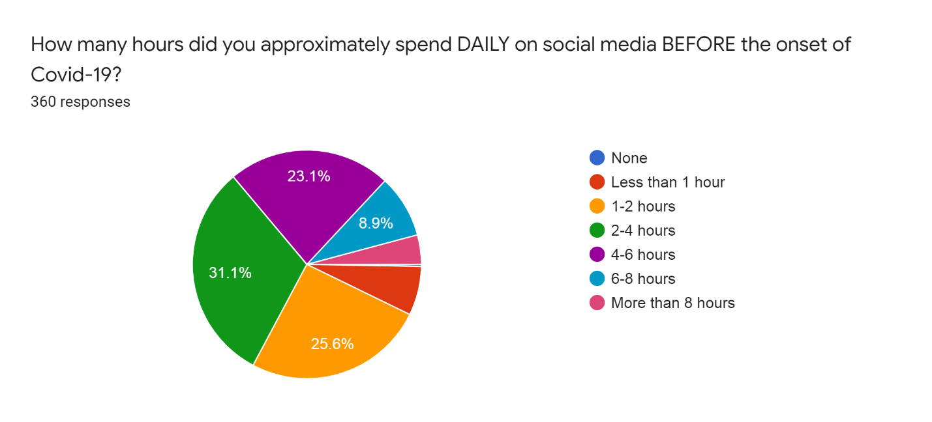
Figure 5: how many hours of social media use before global spread of SARS-CoV-2

After the onset of the spread of the SARSCoV-2, the largest number of respondents, that is, 25 percent recorded using social media for more than eight hours daily every day. The second largest group reported using social media for 4 to 6 hours with a percentage of 22.2 of the total sample. Of all the respondents, 20 percent were recorded to use social media for 6 to 8 hours and 2 to 4 hours. The smallest group of the sample size, that is, 12.8 percent used social media for 1 to 2 hours daily.
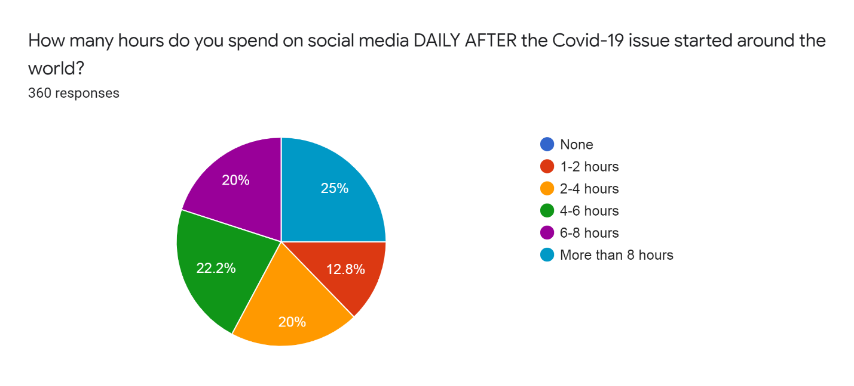
Figure 6: haw much social media use after the global spread of SARS-CoV-2
The social media platform that was found to have the greatest impact on the respondents was WhatsApp with 26.7 percent of the respondents followed by Facebook at 23.6 percent. Twitter was the third most impactful social media platform with 17.2 percent of respondents. Instagram and YouTube have the fourth and fifth most impact with 15.6 and 14.7 percent of the respondents attesting to this. Results indicate that a bulk of social media users prefer to use it privately when alone and individually at 43.5 percent and 32.3 percent respectively. Other users preferred to use social media while with friends and together with friends at 10.6 percent and 8.9 percent. The smallest group used social media with their parents.
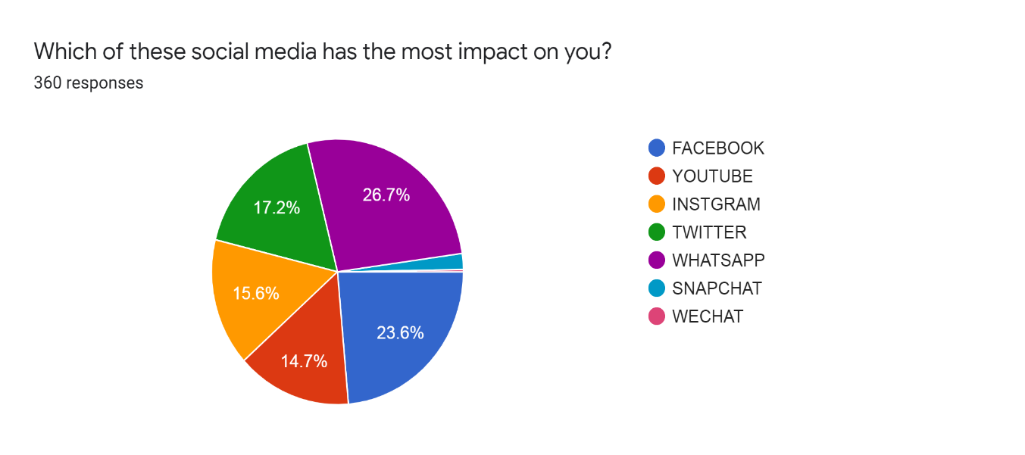
Figure 7: the most impactful social media sites
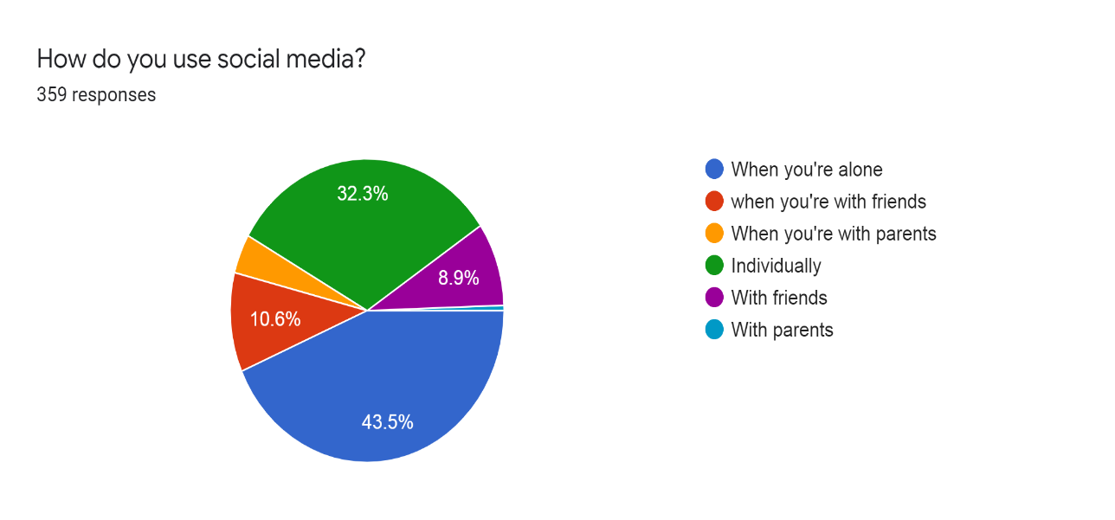
Figure 8: social media use behavior
The results from analysis of the questionnaires indicates that news and reports were the most preferred item to consume on social media with 39.4 percent of respondents citing so. Videos and movies were cited as the second most preferred item followed by studies and research at 36.1 percent and 14.7 percent respectively.
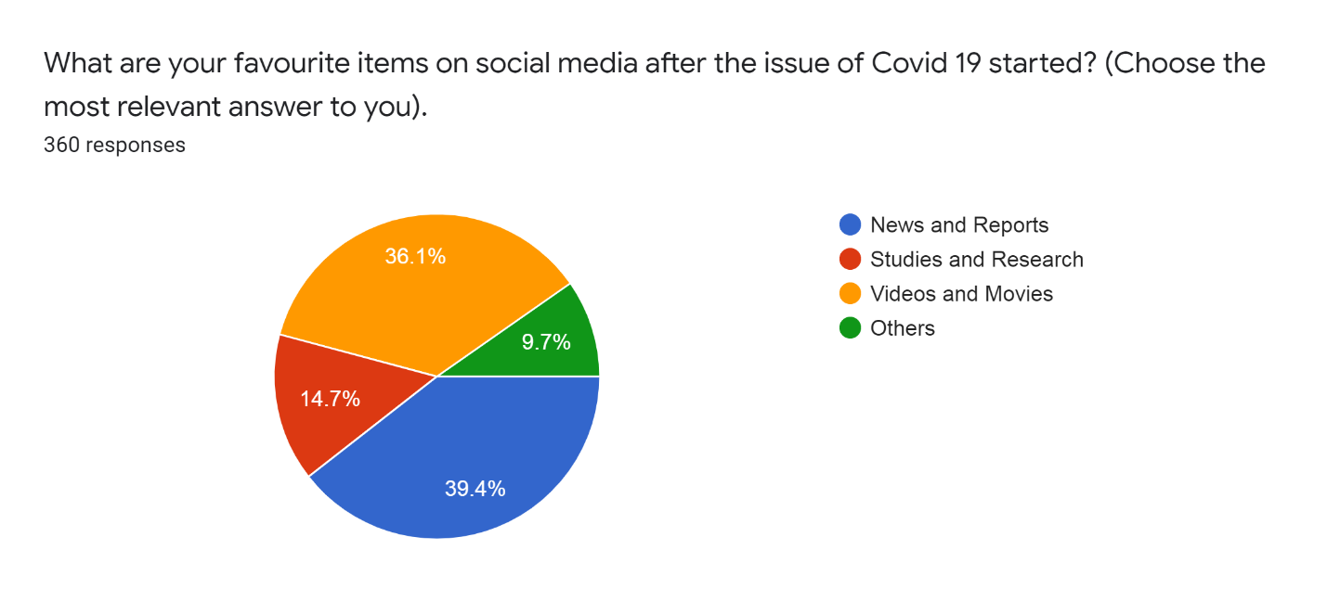
Figure 9: most popular items to view on social media

When investigating the reasons behind social media use, the largest group of respondents (n=110) agreed that social media were the only source of information from which they got to know about the virus. A large group (n=130) also agree that social media provided them with accurate information regarding the virus in the form of news and reports. The largest group recorded (n=160) agreed that they used social media because they helped them feel more psychologically comfortable. The largest group (n=170) agreed that they used social media because they were curious to know more about the virus. Those who wanted to escape from reality through the use of social media had a lower rate of agreeing at (n=90) while (n=125) agreed that they used more social media because they had more time available.
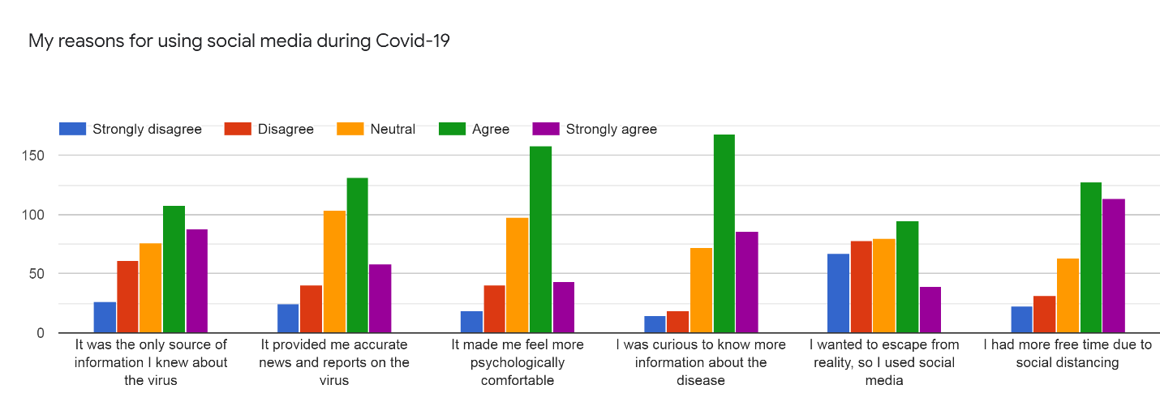
Figure 10: reasons for social media use

When investigating the topics around COVID-19, the largest group (n=175) agree that the use of social media was instrumental in dealing with the virus in terms of symptoms and prevention. A large group of the respondents (n=160) also agree that social media are a good source of reliable scientific information from reliable sources. The largest group of respondents (n=150) were neutral on the issue that information is not based on medical sources. Equal numbers agree and remain neutral that videos are better than news reports and (n=125) are neutral on the fact that information from social media makes them feel more scared.
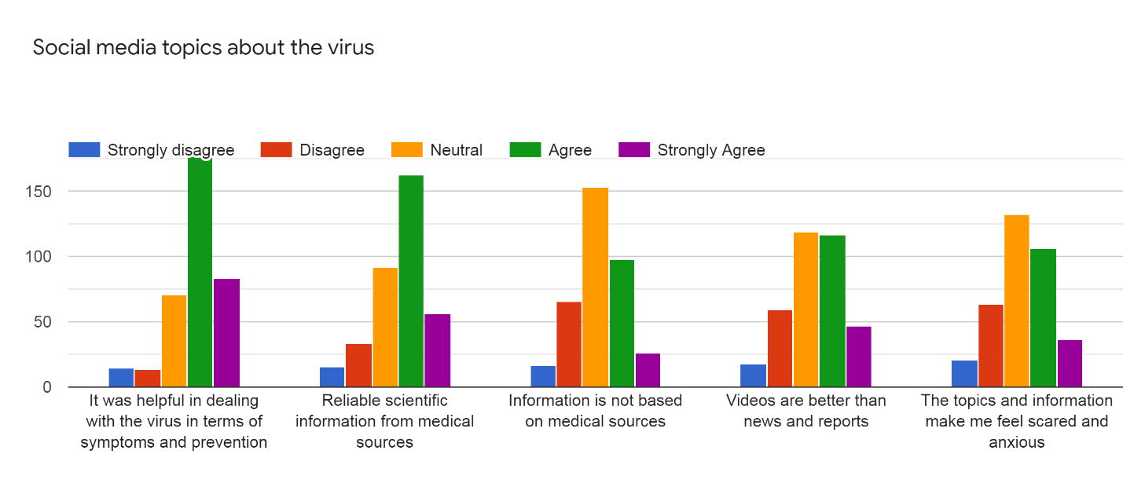
Figure 11: Topics about the Virus

When investigating the role of social media in spreading rumors about the virus, a large number (n=140) agree that social media contribute to the spread of rumors and that rumors. The largest group of the respondents (n=155) also agree that the spread of rumors makes the severity of the virus worse. Respondents (n=145) agree that the spread of rumors increases fear and terror among people. However, a large number of people also recognize that these rumors help to create a culture of medical education. The psychological effects of rumors have affected the respondents who agree (n=130) that rumors have raised fear and panic. The largest group disagreed that rumors make them feel isolated from or caused problems among family members. Many of the respondents agree (n=130) the rumors make them more eager to pick news. However, many (n=170) feel like it is not paramount that they live based on the information from rumors.
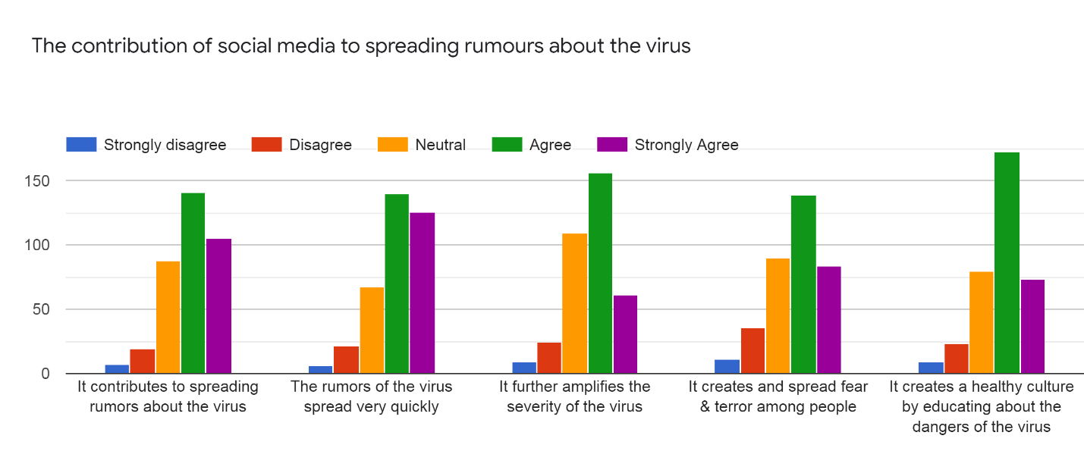
Figure 12: contribution of rumors around the virus
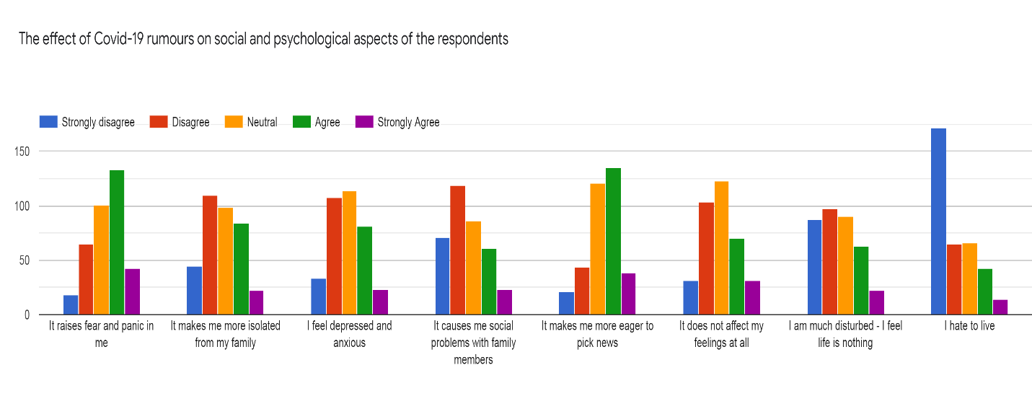
Figure 13: Effects on Psychological Welfare

From the above figures, it is evident that the use of social media has increased tremendously after the onset of the SARSCoV-2 which caused the COVID-19 disease. This can be attributed to the fact that up to 49 percent of the respondents are students. Seeing as the breakout of COVID-19 prompted the closure of schools, these individuals have had a lot more time to spend on social media than they have ever had before.
It is evident that the public has a high level of trust in social media platforms since the largest number of respondents cited that social media were the only source of information they had regarding the virus and that this platform provided them with accurate information about the virus. Psychologically, many turned to social medial to help them feel more comfortable during this time of crisis. Curious individuals also turned to social media to get information. The use of social media has helped to inform the public about the symptoms and prevention measures that can be used against COVID-19. There is also reliable scientific and medical information available on social media.
However, rumors have also been spread through the use of social media, which has been employed to create fear and panic. The respondents identify that information about the COVID-19 disease bring a neutral level of fear and panic. However, many agree that the rumors do bring a heightened level of fear and panic. This further exacerbates the seriousness of the outbreak. The spread of rumors has also created an atmosphere of uncertainty where many people welcome the idea of death. It has also caused more anxiety to pick apart news items.
It is, therefore, evident that rumors can cause the escalation of a crisis like the breakout of COVID-19 due to how the information affects the psychology of those who use social media (Gao et al., 2020). The public is aware that not all information from social media is credible. However, most of them still use social media as a primary source of information. This means that many people in the public remain vulnerable to misinformation through social media and the psychological effects that accompany these rumors.

- Limitations and Recommendations
The efficiency of the study is grossly limited by the fact that the spread of the COVID-19 disease is still ongoing, and the role of social media can dramatically evolve during this period. For this reason, it fails to be completely comprehensive. Validity and generalizability are affected by the size of the sample used for study. Since this is a quantitative study, it is important to use a large study sample, which will enable identification of more diverse opinions. However, the sample used for the study is rather small, which means that it will be difficult to extrapolate the findings to other populations.
The validity and generalizability of the research findings is also affected by the sample chosen for study. The sample was effective to show phenomenon occurring in the Asian Pacific and the Middle East since the individuals who responded to the questionnaire came predominantly from these regions. This means that it may be harder to generalize the findings to other groups with different cultural and social organization like western communities (Surveillances, 2020). However, the research still remains to be instrumental for further investigation into how social media can be misused to cause a shift in the psychology of the public.
Firstly, it is important to carry out further research while using a predominantly western sample size. This will help to identify any trends that differ based on the underlying culture of the respondents. More research should also be carried out to find out how the spread of rumors affected the decisions made by the public and how this contributed to the spread of the COVID-19 disease. From the above findings, it is evident that rumors and misinformation did have an effect on the psychology of individuals, thus, this information must have affected the behavior of people. Further qualitative analysis from healthcare practitioners and responders can give more insight into how individuals have mitigated the psychological stress during this period.
- Conclusion
In conclusion, the use of social media has become central to our daily lives, especially during a time of crisis like the spread of the COVID-19 disease. Social media have been used as a source of information by many people during this time, which has shaped the response of the public to the crisis. However, it is evident that social media do not always have reliable information. This lack of reliable information has exacerbated the circumstances by encouraging the spread of misinformation and unverified data. The spread of rumors through social media has negatively affected the psychological well-being of individuals due to the increase of fear and terror surrounding incidents of the COVID-19 disease.
The spread of rumors has also created a feeling of global hysteria, with many individuals becoming more aware of the implications of their mortality. However, despite this, social media have been successfully used to dispatch accurate information about the SARSCoV-2 virus that causes the COVID-19 disease. This has facilitated the speedy response by individuals to prevent them from contracting the illness. The use of social media has also helped to offer psychological support for people who have been isolated from their normal lives. It is, therefore, evident that during this period of crisis, social media are a double-edged sword with both positive and negative psychological effects, with a bulk of the adverse emotional impacts being a result of rumors and false information.

References
Anderson, R. M., Heesterbeek, H., Klinkenberg, D., & Hollingsworth, T. D. (2020). How will Country-Based Mitigation Measures influence the Course of the COVID-19 epidemic?. The Lancet, 395(10228), 931-934.
Boulos, M. N. K., & Geraghty, E. M. (2020). Geographical Tracking and Mapping of Coronavirus Disease COVID-19/Severe Acute Respiratory Syndrome Coronavirus 2 (SARS-CoV-2) Epidemic and Associated Events around the World: How 21st Century GIS Technologies are supporting the Global Fight against Outbreaks and Epidemics: BioMed Central.
Cascella, M., Rajnik, M., Cuomo, A., Dulebohn, S. C., & Di Napoli, R. (2020). Features, Evaluation and Treatment Coronavirus (COVID-19). In StatPearls [Internet]. StatPearls Publishing.
Chung, R. Y.-N., & Li, M. M. (2020). Anti-Chinese Sentiment during the 2019-nCoV Outbreak. The Lancet, 395(10225), 686-687.
Cinelli, M., Quattrociocchi, W., Galeazzi, A., Valensise, C. M., Brugnoli, E., Schmidt, A. L., Zola, P., Zollo, F., & Scala, A. (2020). The COVID-19 Social Media Infodemic. arXiv preprint arXiv:2003.05004.
Cinelli, M., Quattrociocchi, W., Galeazzi, A., Valensise, C. M., Brugnoli, E., Schmidt, A. L., ... & Scala, A. (2020). The COVID-19 Social Media Infodemic. arXiv preprint arXiv:2003.05004.
Depoux, A., Martin, S., Karafillakis, E., Preet, R., Wilder-Smith, A., & Larson, H. (2020). The Pandemic of Social Media Panic travels faster than the COVID-19 Outbreak. Journal of Travel Medicine.
Francis, T. J. (2020). Waiting for COVID‐19. Journal of Paediatrics and Child Health.
French, M., & Monahan, T. (2020). Disease Surveillance: How Might Surveillance Studies Address COVID-19? Surveillance & Society, 18(1), 1-11.
Gao, J., Zheng, P., Jia, Y., Chen, H., Mao, Y., Chen, S., ... & Dai, J. (2020). Mental Health Problems and Social Media Exposure during COVID-19 outbreak. Plos one, 15(4), e0231924.
Gralinski, L. E., & Menachery, V. D. (2020). Return of the Coronavirus: 2019-nCoV. Viruses, 12(2), 135.
Hellewell, J., Abbott, S., Gimma, A., Bosse, N. I., Jarvis, C. I., Russell, T. W., ... & Flasche, S. (2020). Feasibility of controlling COVID-19 Outbreaks by Isolation of Cases and Contacts. The Lancet Global Health.
Ho, C. S., Chee, C. Y., & Ho, R. C. (2020). Mental Health Strategies to Combat the Psychological Impact of COVID-19 beyond paranoia and panic. Ann Acad Med Singapore, 49(1), 1-3.
Huang, C., Wang, Y., Li, X., Ren, L., Zhao, J., Hu, Y., ... & Cheng, Z. (2020). Clinical Features of Patients Infected with 2019 Novel Coronavirus in Wuhan, China. The Lancet, 395(10223), 497-506.
Kouzy, R., Abi Jaoude, J., Kraitem, A., El Alam, M. B., Karam, B., Adib, E., Zarka, J., Traboulsi, C., Akl, E. W., & Baddour, K. (2020). Coronavirus Goes Viral: Quantifying the COVID-19 Misinformation Epidemic on Twitter. Cureus, 12(3).
Kupferschmidt, K. (2020). Preprints bring ‘firehose’of outbreak data: American Association for the Advancement of Science.
Li, C., Chen, L. J., Chen, X., Zhang, M., Pang, C. P., & Chen, H. (2020). Retrospective Analysis of the Possibility of Predicting the COVID-19 Outbreak from Internet Searches and Social Media Data, China, 2020. Eurosurveillance, 25(10).
Lipsitch, M., Swerdlow, D. L., & Finelli, L. (2020). Defining the Epidemiology of COVID-19—Studies needed. New England Journal of Medicine.
Liu, Y., Gayle, A. A., Wilder-Smith, A., & Rocklöv, J. (2020). The Reproductive Number of COVID-19 is higher compared to SARS coronavirus. Journal of travel Medicine.
Manderson, L., & Levine, S. (2020). COVID-19, Risk, Fear, and Fall-out.
Meng, L., Hua, F., & Bian, Z. (2020). Coronavirus Disease 2019 (COVID-19): Emerging and Future Challenges for Dental and Oral Medicine. Journal of Dental Research, 0022034520914246.
Pan, X., Ojcius, D. M., Gao, T., Li, Z., Pan, C., & Pan, C. (2020). Lessons learned from the 2019-nCoV Epidemic on Prevention of Future Infectious Diseases. Microbes and Infection, 22(2), 86-91.
Parry, N. M. (2020). COVID-19 and Pets: When Pandemic Meets Panic. Forensic Science International: Reports, 100090.
Remuzzi, A., & Remuzzi, G. (2020). COVID-19 and Italy: What Next?. The Lancet.
Sun, K., Chen, J., & Viboud, C. (2020). Early Epidemiological Analysis of the Coronavirus Disease 2019 Outbreak based on Crowdsourced Data: A Population-Level Observational Study. The Lancet Digital Health.
Surveillances, V. (2020). The Epidemiological Characteristics of an Outbreak of 2019 Novel Coronavirus Diseases (COVID-19)—China, 2020. China CDC Weekly, 2(8), 113-122.
Velavan, T. P., & Meyer, C. G. (2020). The COVID-19 Epidemic. Trop Med Int Health, 25(3), 278-280.
World Health Organization. (2020). Coronavirus Disease 2019 (COVID-19): Situation Report, 72.
Zheng, Y. Y., Ma, Y. T., Zhang, J. Y., & Xie, X. (2020). COVID-19 and the Cardiovascular System. Nature Reviews Cardiology, 17(5), 259-260.
Zu, Z. Y., Jiang, M. D., Xu, P. P., Chen, W., Ni, Q. Q., Lu, G. M., & Zhang, L. J. (2020). Coronavirus disease 2019 (COVID-19): A Perspective from China. Radiology, 200490.

